1- Check for login if yes no need to login again : not working for new version

2- Task details I will share the design with you api is ready (text and images or file uploaded do you remember)

3- adding something in application start after splash like announcing image gallery or about us because apple may refuse any app start with login I'll share with you design

4- Appling bilingual

5 when updating task data not update

0561293131@fas.com

2) Task details

[http://hosnims-001-site1.gtempurl.com/api/Employee/ProjectTaskLog//api/Employee/ProjectTaskLog/{ProjectTaskId}](http://hosnims-001-site1.gtempurl.com/api/Employee/ProjectTaskLog//api/Employee/ProjectTaskLog/%7bProjectTaskId%7d)

**ProjectTaskId = 4088**

<http://hosnims-001-site1.gtempurl.com/api/Employee/ProjectTaskLog/4088>

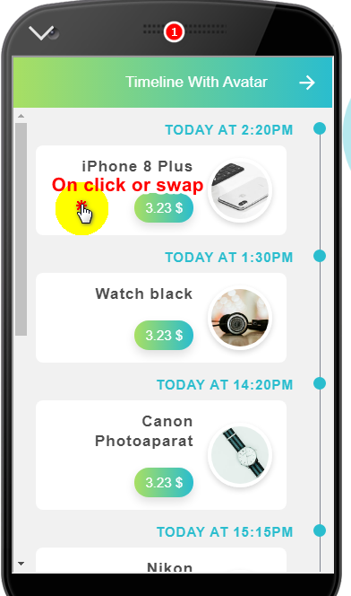 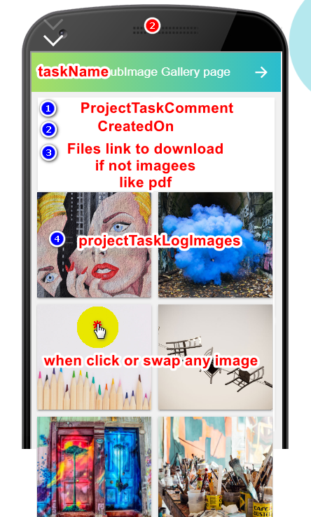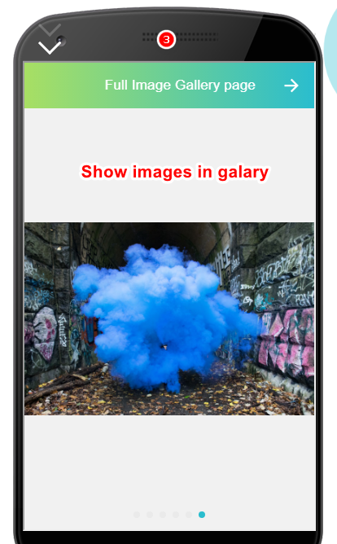

3- adding something in application start after splash like announcing image gallery or about us because apple may refuse any app start with login I'll share with you design

**Categuries**

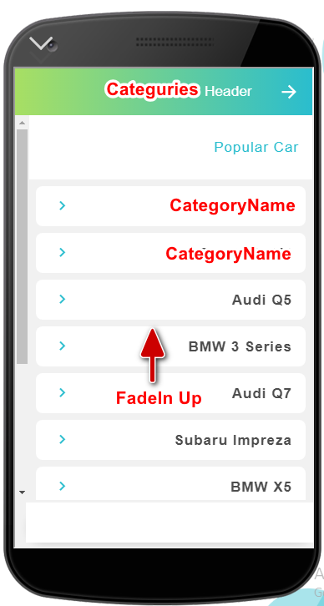[http://hosnims-001-site1.gtempurl.com/api/Product/Category](http://hosnims-001-site1.gtempurl.com/api/Product/Category   )

[](http://hosnims-001-site1.gtempurl.com/api/Product/Category   )

Products by catigury id

<http://hosnims-001-site1.gtempurl.com/api/Product/Product?id=1>

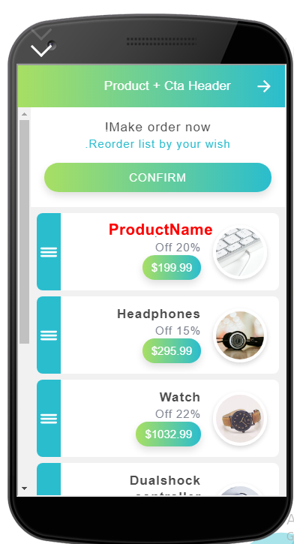

Product details

<http://hosnims-001-site1.gtempurl.com/api/Product/Product/6>

